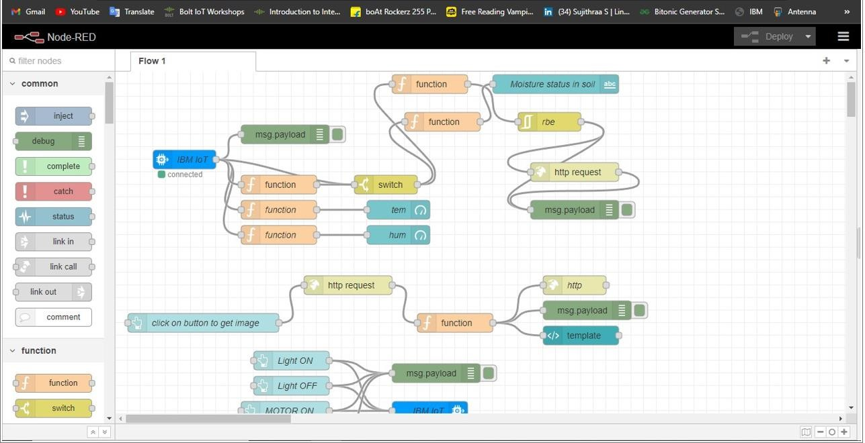**Sprint – 2 Softwarecreation**

|  |  |
| --- | --- |
| **Date** | 19 November 2022 |
| **TeamID** | PNT2022TMID |
| **ProjectName** | IoT Based Smart Crop Protection System For Agriculture. |

**Description:**

According to our sprint-2 planning we’ve created the accounts in the required platforms (Node-red, Cloudant, Cloud object storage, Watson) and linked with our project.

**Node-Red:**

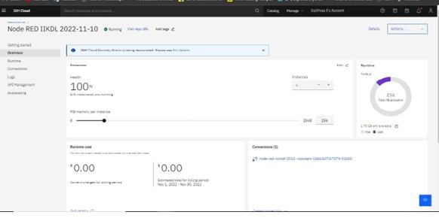

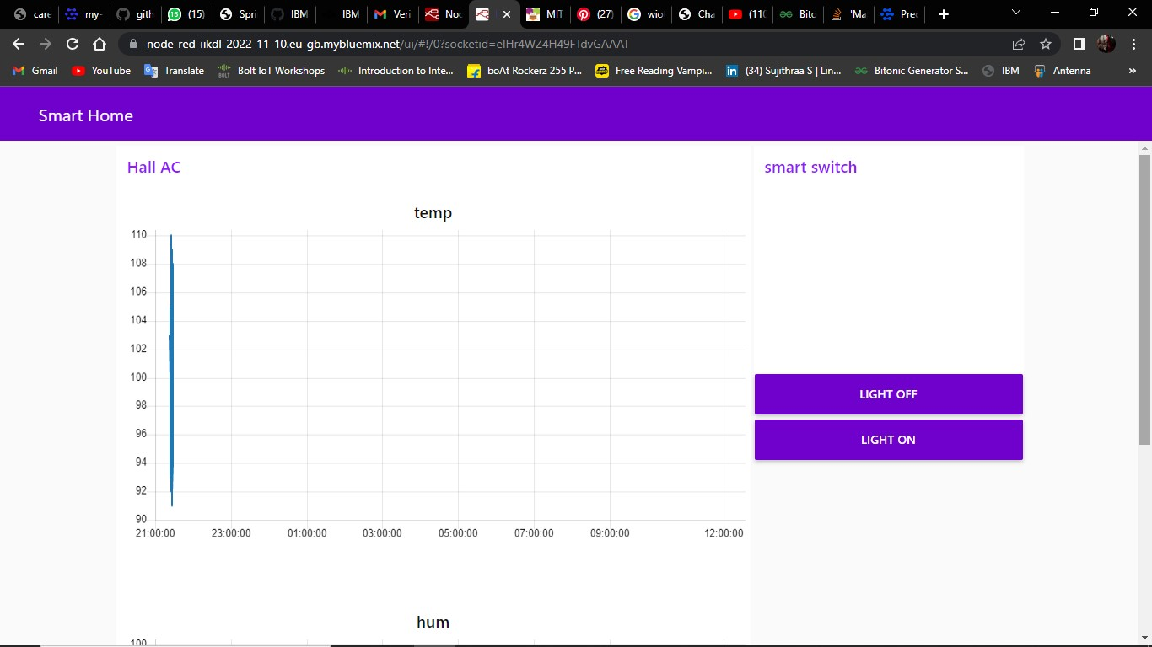

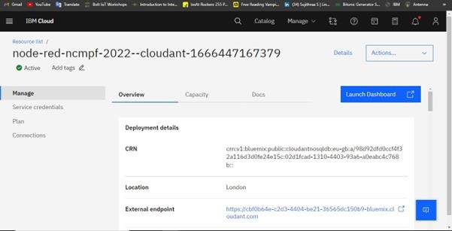**Cloudant:**

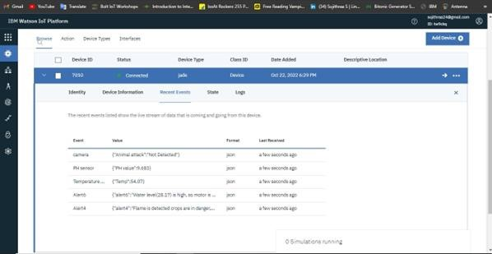**Cloud Object Storage:**

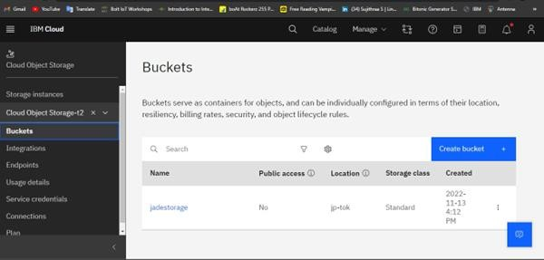

**Watson:**